Beijing International Travel Healthcare Center
Announcement
Since May 8th, 2008, partial physical examinations and certificate of vertification have been done at HaiDian Clinic of Beijing International Travel Health Center in order to improve examination environment and service quality for foreigners.
Starting September 1st, 2008, Beijing international travel health center (HePingLi) will no longer handle physical examination and verification services. All services shall be officially handled by HaiDian Clinic.
Sorry for any inconvenience caused.
Haidianclinic address: 10# De zheng street, haidian District, Beijing.
Tel: 82403675 (working time)
Notice:
1. Please bring your passport or ID with you;
2. 3 photos;
3. No breakfast for physical examination;
4. Working time: AM8:30——11：00 from Monday to Friday;
5. Fee:
physical examination：644.50 RMB
certification: 60.00 RMB per copy
physical examination for international students (Please show your valid student identification or letter of admission from an educational institute): 346.00 RMB.
6、Subway and Bus Route: Dazhongsi Subway Station , line 13 (dongzhimen direction) to Xierqi Subway Station,Exit B2--- Chengtiexierqi Bus Station, Bus 963 to Xibeiwang Zhenzhengfu Bus Station
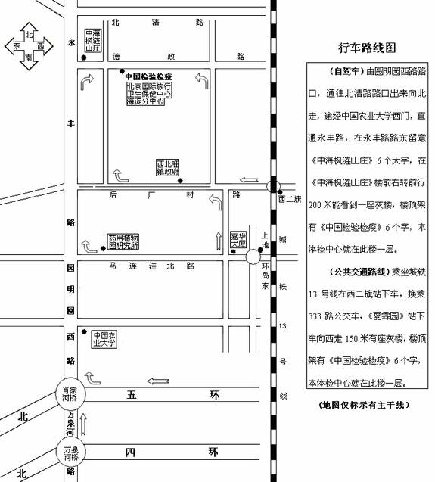

路线示意图00.bmp

